|  |  |
| --- | --- |
| Year 9 Science:  Electricity and Thermal Energy Test (Ex) | |
| Multiple Choice:  Short Answer:  Mark: | ____ / 10  ____ / 61  ____ / 71  ____ % |

**Multiple Choice Answers**

|  |  |  |  |  |  |  |  |  |  |  |
| --- | --- | --- | --- | --- | --- | --- | --- | --- | --- | --- |
| **Question** | **Response** | | | |  | **Question** | **Response** | | | |
| 1 | A | B | C | D |  | 6 | A | B | C | D |
| 2 | A | B | C | D |  | 7 | A | B | C | D |
| 3 | A | B | C | D |  | 8 | A | B | C | D |
| 4 | A | B | C | D |  | 9 | A | B | C | D |
| 5 | A | B | C | D |  | 10 | A | B | C | D |

**Short Answer**

Write your answers in the spaces provided.

**Question 1: Thermal Energy and Temperature**

1. Explain the difference between thermal energy and temperature. (2)

__________________________________________________________________________________________________________________________________________________________________________________________________________________________________________________________________________________________________________________________________________

1. What is meant by the phrase “thermal equilibrium”? Give an example as part of your response. (3)

__________________________________________________________________________________________________________________________________________________________________________________________________________________________________________________________________________________________________________________________________________

1. 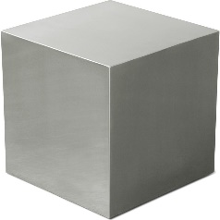Which of the objects has a larger amount of thermal energy? Explain why. (2)

______________________________________________

______________________________________________

______________________________________________

100 g

20°C

100 g

60°C

______________________________________________

__________________________________________________________________

1. 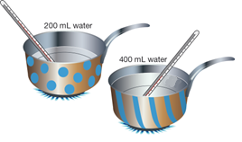200 mL of cold water is heated in the spotted saucepan, and 400 mL of cold water is heated in an identical striped saucepan. If both saucepans are given the same amount of energy, which one will have the larger increase in temperature? Give an explanation for your choice. (2)

____________________________________________________________________________________________________________________________________________________________________________________________________________________________________________________________________________________________________________________________________________________________________________________________________________

**Question 2: Transfer of Thermal Energy**

1. For the situations below, state the form of thermal energy transfer and explain how the energy is transferred. (5)
2. The interior of a room warms up soon after the heater has been turned on.

___________________________________________________________________________________________________________________________________________________________________________________________________________________________________________________________________________________________________________________________________________________________________________________________________________________________________________

1. Allan feels his body getting warm as he plays cricket on a summer day.

___________________________________________________________________________________________________________________________________________________________________________________________________________________________________________________________________________________________________________________________________________________________________________________________________________________________________________

1. 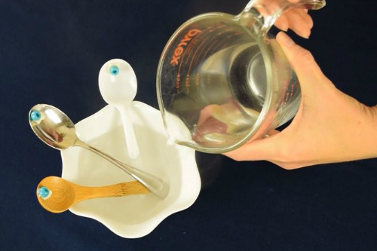A student set up an experiment by sticking a plastic bead to three different spoons with wax. They sat the ends of the spoons in a bowl and then poured hot water into the bowl.
   1. Which method of heat transfer is being used in this situation? _____________________ (1)
   2. Out of the three spoons (wood, metal or plastic), which bead should fall off first when the wax melts? Explain your choice. (2)

____________________________________________________________________________________________________________________________________________________________________________________________________________________________________________________

**Question 3: Electrostatic Force**

1. A balloon is rubbed on your hair, transferring electrons to the balloon. Describe the electrostatic charge on each object. (1)

____________________________________________________________________________________________________________________________________

1. Explain why your hair spreads out when it is electrostatically charged. (2)

________________________________________________________________________________________________________________________________________________________________________________________________________________________________________________________________________

1. Explain why your hair is attracted to the balloon. (2)

________________________________________________________________________________________________________________________________________________________________________________________________________________________________________________________________________

**Question 4: Series and Parallel Circuits**

1. Explain the difference between a series and a parallel circuit. Draw a diagram of each type of circuit with two globes in each. (4)

__________________________________________________________________________________________________________________________________________________________________________________________________________________________________________________________________________________________________________________________________________

1. Compare the brightness of globes in series and in parallel to the brightness of a single globe. (2)

__________________________________________________________________________________________________________________________________________________________________________________________________________________________________________________________________________________________________________________________________________

1. What type of circuits are used in houses? Give two reasons why these circuits are used. (3)

__________________________________________________________________________________________________________________________________________________________________________________________________________________________________________________________________________________________________________________________________________

**Question 5: Drawing Circuits**

Neatly draw each of the following circuits, using the correct symbols, based on the descriptions below.

1. A circuit with a battery, a motor, a resistor and an open switch in series. (3)
2. A circuit with a power source in parallel with a globe and a bell, with a switch that controls both the globe and the bell. (3)
3. A battery in series with a closed switch and a globe, in parallel with a 20 ohm resistor and a globe in series. (4)

**Question 6: Measuring Current and Voltage**

Look at the circuit below and answer the questions that follow.

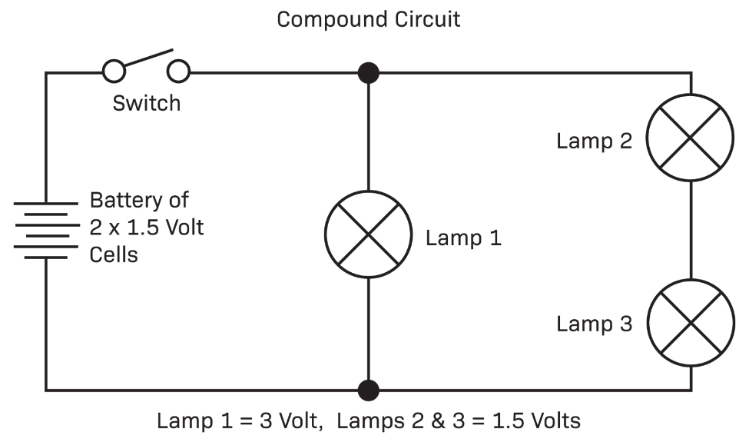

Globe 3

Globe 2

Globe 1

1. Redraw the circuit to include an ammeter to measure the current of globe 1 and a voltmeter to measure the voltage of globe 3. (2)
2. Explain how and why you placed the ammeter where you did in the circuit. (2)

________________________________________________________________________________________________________________________________________________________________________________________________________________________________________________________________________

1. Explain how and why you placed the voltmeter where you did in the circuit. (2)

________________________________________________________________________________________________________________________________________________________________________________________________________________________________________________________________________

1. 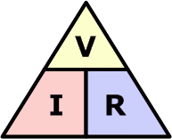Use the formula to complete the Ohm’s Law calculations. (5)
   1. A light bulb has a resistance of 10 ohms and a voltage of 50 volts. What is the maximum current that can flow through the light bulb?

|  |  |  |  |
| --- | --- | --- | --- |
| **Given** | **Equation** | **Work** | **Final Answer** |
|  |  |  |  |

* 1. A toaster produces 12 ohms of resistance in a circuit. If the current through the toaster is 10 Amperes, what is the voltage of the circuit?

|  |  |  |  |
| --- | --- | --- | --- |
| **Given** | **Equation** | **Work** | **Final Answer** |
|  |  |  |  |

**Question 7: Specific Heat Capacity**

Refer to the table of specific heat capacities to answer the following questions.

1. Which of the materials in the table will heat up the fastest? Explain why. (2)

______________________________________________________________________________________________________________________________________________________________________________________________________

1. A student has an unidentified cube of silver metal. How could they work out which metal it is? (2)

______________________________________________________________________________________________________________________________________________________________________________________________________

1. A pot is filled with 9 kg of water at 10°C. How much heat energy would be needed to raise the temperature to 60°C? (2.5)

Q

m

c

ΔT

1. What is the mass of a glass block if its temperature has increased from 50°C to 100°C after absorbing 301, 500 joules of energy? (2.5)

|  |  |
| --- | --- |
| **Substance** | **Specific Heat (J/kg/°C)** |
| Water | 4200 |
| Iron | 440 |
| Glass | 670 |
| Aluminium | 900 |
| Lead | 130 |

**Multiple Choice**

**End of Test**

**Do not write on this sheet. Circle your choice on the first page of your test paper.**

1. Your hand feels cold as an ice-block melts on it. Identify the correct explanation for this process.
   1. Thermal energy transfers from the ice-block into your hand by conduction.
   2. Thermal energy transfers from your hand to the ice-block by conduction.
   3. Thermal energy transfers from the ice-block into your hand by radiation.
   4. Thermal energy transfers from your hand to the ice-block by radiation.
2. Pool blankets are used to trap heat in a pool overnight. Four types of pool blanket were tested on identical pools. Each pool was heated to 28°C, and covered with a pool blanket in the evening. The temperature of each pool was measured in the morning. The results are in the table below.

|  |  |  |  |  |
| --- | --- | --- | --- | --- |
| **Pool Blanket** | **Silverline** | **Hot Stuff** | **Luxury Liner** | **Thermospecial** |
| Temperature at 9 a.m. (°C) | 26 | 24 | 25.5 | 23.5 |

The blankets listed in order from most effective to least effective insulator are:

* 1. Hot Stuff, Silverline, Luxury Liner, Thermospecial
  2. Silverline, Luxury Liner, Hot Stuff, Thermospecial
  3. Luxury Liner, Thermospecial, Hot Stuff, Silverline
  4. Thermospecial, Hot Stuff, Luxury Liner, Silverline

1. A puddle dries up when it absorbs heat from the sun. Which method of heat transfer is causing this to happen?
   1. Convection
   2. Radiation
   3. Evaporation
   4. Conduction
2. Which statement about conventional current and electron flow is correct?
   1. Electron flow travels from positive to negative.
   2. Conventional current travels from negative to positive.
   3. Conventional current travels from positive to negative.
   4. They both travel in the same direction.
3. 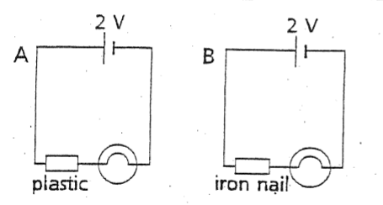Which statement about the two circuits is true?
   1. The globes in both circuits will glow.
   2. The globes in neither circuit will glow.
   3. The globe in circuit A will glow, but the globe in circuit B will not.
   4. The globe in circuit B will glow, but the globe in circuit A will not.
4. A person charges two balloons by rubbing them against their hair. They then held them together. What be most likely to happen?
   1. They will attract each other.
   2. They will repel each other.
   3. Nothing will happen.
   4. The balloons will pop.
5. When the resistance of a circuit increases, the current:
   1. Increases
   2. Decreases
   3. Stays the same
   4. None of the above
6. What is the voltage of an object with 5 amperes of current and 15 ohms of resistance?
   1. 75 volts
   2. 10 volts
   3. 15 volts
   4. 3 volts
7. Which group contains materials that are all good electrical conductors?
   1. Copper, silver, iron
   2. Tin, plastic, iron
   3. Wood, rubber, plastic
   4. Rubber, copper, cardboard
8. The unit used for resistance is the:
   1. Ohm
   2. Volt
   3. Ampere
   4. Joule